2020 November Class Project

National University of Computer & Emerging Sciences FAST

Department of Computer Science

Course Number CS118

Course Title Programming Fundamentals SE&DS

|  |  |
| --- | --- |
| Title of Course Work | **Class Project (Fire-DP)** |
| Time/ Duration Allowed | **3 Weeks** |

Instructions to Candidates:

Total Marks: 10% (6+4)

Part-I

Your programming code must include the following contents. Now advance topics and other graphic design methods are allowed to use.

Nested loops

Functions

Functions with default parameters

Arrays

Use of Static and Unitary etc.

Pointers (Bonus)

Part-II

Describe Problem Abstract (One paragraph)

Live Demo & Q&A

______________________________________________________________________________ **For this assignment/ project you will be supplied with:**

**Fireworks Drawings with Programming (Fire-DP)**

**Assessment**

This project emphasizes on problem solving with team work efforts. Only core programming with given contents are allowed to use. Fancy and colourful appearances are not necessary to adopt. Do not use fractal.

CASE BRIEF

**Introduction**

There are various shapes of fireworks are available with different types such as fish, palm etc. One different shape/ type is given to each group. You need to draw and manage programming as you have done using asterisks (*) for making triangle, square boxes and pyramids (in class/ lab) without hard coding (Figure-4). You can use two dimensional array to resolve issues of coordinates as shown in figure 2. Rough prototypes are shown in figure-3.

Produce problem abstract followed by Implemtation.



Figure-1: Fireworks

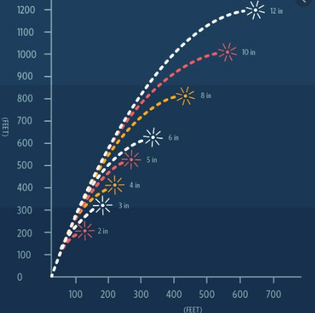

Figure-2: Curve graphs Figure-4: Basic drawing

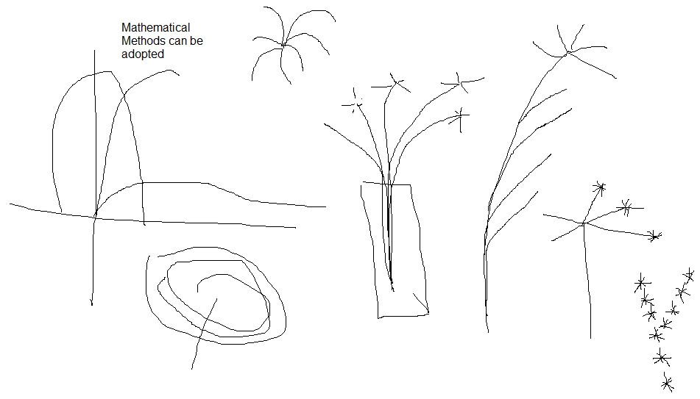

Figure-3: Rough prototypes of shapes

**National University of Computer & Emerging Sciences**

**Computer Science Department**

**HOME WORK - ASSIGNMENT COVER SHEET**

COURSE TITLE Programming Fundamentals COURSE CODE CS-118

INSTRUCTOR 

EJA

Z AHMED, MYRA KHALID, SHEHRYAR

TYPE

(

Please tick

)

pisp

Indiv. Group

ASSIGNMENT NO

1

ASSIGNMENT

Class Project (Fire-DP)

HAND OUT DATE

26-

NOV

-2020

DUE DATE

15-

NOV

-2020

ESTIMATE TIME

30

Hours

|  |  |
| --- | --- |
| ASSESSMENT CRITERIA (or attached) | % Mark |
| Instructions to Candidates:  Max of 3 or min of 2 students are allowed in a group |  |
| |  |  | | --- | --- | | 20I-0697 | DS-N | | 20I-2416 | DS-N | |  |  |   TO BE COMPLETED BY STUDENT (Who submitted) GROUP MEMBERS ID  NAME _____Muhammad Wisal_______  ID NO _____20I-0697_______________  Time Taken: 25 hrs approx.  DECLARATION: I/We declare that this Coursework is my/our group’s own work  SIGNATURES: Member-1: Muhammad Wisal  Member-2: Yasin Jodat | |

GRADE/ MARK AWARDED COMMENTS

INSTRUCTOR’S SIGNATURE

DATE